Conductivity Accuracy of Two Open Source SeaLabMOS CTDs: A Tabletop and In-Situ Comparison with an RBRconcerto³

Sophie Scopazzi Aspect Wave LLC, Owner | www.sophiescopazzi.com
MSc Operational Oceanography, Rutgers University, 2024
(415) 720 – 5883 | sscopazzi@pm.me
Karl Nordhoff Cal Poly Maritime Academy, Mechanical Engineering student (senior)

ABSTRACT
Using an RBRconcerto³ as the calibrated reference, a SeaLabMOS CTD equipped with an Atlas Scientific salinity sensor was evaluated in a laboratory setting against conductivity standards, laboratory-prepared solutions, and water samples taken from estuarine and coastal seawater. An in-situ comparison between a second identical SeaLabMOS CTD was completed in Mare Island Strait offshore Vallejo, California in conjunction with the RBR. Despite the initial manufacturer-specified calibration procedure for the Atlas Scientific salinity sensor, neither open source system performed accurately “out of the box”, per USGS standards for electrical conductivity samples to have less than 3% error. A correction is required to account for the inherent inaccuracies of the Atlas Scientific salinity sensor. Both SeaLabMOS CTDs required a different type of correction; thus, two data correction methods are proposed. After an initial method to determine which to utilize, a scalar or quadratic correction is applied to the sensor’s electrical conductivity values during data post-processing before the final salinity calculation. The corrected electrical conductivity was independently shown to be within 1.7% of the RBR's reference value when above 22 mS/cm and 3–5% when below. The absolute accuracy of the final salinity data product, following correction methods, was ±0.25 PSU of the reference.

KEYWORDS
modular embedded systems, open source, citizen science, atlas scientific
INTRODUCTION
Open source systems built using commercial-off-the-shelf (COTS) components can, due to lower cost, afford access to oceanographic data otherwise out of reach of citizen scientists, low-income and underserved communities, and even academic institutions. This need for hardware has been met by systems like the OpenCTD[1] and the SeaLabMOS[2] family of systems, both of which utilize the Atlas Scientific EZO™ Conductivity Circuit and Conductivity Probe K 1.0. In this work, the combination of the circuit and probe is collectively referred to as the EZO. The manufacturer reports the EZO’s accuracy with two different numbers: the probe’s data sheet says ±2% [3] while the circuit’s Conductivity Accuracy Graph [4, p. 2] shows less than 1% error between a conductance range of 0.065 – 9,000 mS/cm. It is unclear whether the reported errors of the probe and circuit should be taken individually, which is correct, or if the errors stack.
Research with a bare EZO in a laboratory setting with the sensor not in an embedded system was completed by Stephanie G. Fulton, et al. [5]. The authors noted more studies were needed to evaluate “sensor performance … across different … data collection platform configurations, and over longer periods of deployment.” This work seeks to help answer that call: how accurate is the EZO within an embedded system capable of in-situ oceanographic deployments?
The following USGS definition[6] will be used as a yardstick to determine whether the open source systems and their salinity sensors used are accurate:
“After the meter is calibrated, check the accuracy of the calibration by measuring the specific conductance of at least one additional standard near the expected range of environmental values to be measured. Measurements of specific conductance standards that are within ±5 μS/cm of the certified values for measurements ≤100 μS/cm or ±3 percent of the certified values for measurements >100 μS/cm are considered accurate and do not warrant recalibration.”

Salinity Background
The salinity of water refers to the presence of salt ions within the liquid. The ions can be positively or negatively charged and conduct electricity in the presence of electro-magnetic fields. Therefore, a liquid’s salinity can be measured by the strength of its electrical response. A liquid that has a greater response to the presence of electrical input, meaning a higher conductivity, has a higher salinity [7].

The two sensors used in these experiments utilize different fundamental electrical principles, direct current voltage and alternating current inductance, to measure the liquid’s electrical conductivity (EC). The measurement method used by a sensor does not necessarily imply that it is a more sensitive or accurate sensor: high quality sensors of both kinds exist.

The RBRconcerto³ uses an inductive conductivity sensor wherein two coils of wire are placed a fixed distance apart on a common central axis. To measure conductivity, alternating current is passed through one wire which generates an induced current parallel to the common axis of the coils. The liquid medium carries this current to the second coil. The strength of this current is based on the medium's conductivity. The energized liquid medium then induces an alternating current in this second coil, where the strength of the induced current is measured [8].

The SeaLabMOS CTD utilizes a conductive sensor, the EZO. The probe measures a liquid’s ability to conduct electrical current between a positively charged plate to an opposing and negatively charged plate [3]. The physical properties of a conductive sensor, its plate size and distance, create what is known as the “cell-constant”, a quantity that is often measured rather than calculated in specific calibration solution(s). Sensors of different cell constants are used to measure different ranges of EC, meaning it is important to select a sensor that covers the full range of values to be measured [9].

METHODOLOGY
Systems Used
- An RBRconcerto³ calibrated by RBR on April 30th, 2026 with less than 0.002 mS/cm of error.
- Two 2.0” schedule 40 PVC CTDs from the SeaLabMOS[2] family of systems calibrated June 10th, 2026 by Sophie Scopazzi per the manufacturer instructions and the SeaLabMOS Build Manual [10]. They are labeled MIS_1 and MIS_2.
This salinity sensor investigation was completed within a broader system deployment currently in prep for presentation at OCEANS Monterey 2026, the full scope of which is outside this paper's deep-dive. Suffice to say, the SeaLabMOS CTD MIS_1 was deployed in Mare Island Strait, Vallejo, California for 5 days, removed and kept dry, then tested in the lab 18 days later. SeaLabMOS MIS_2 was used during the same spatial deployment, removed and kept dry, then used for casts with holds approximately every 1.5 m. Both casts with holds were deployed in conjunction with the RBR in Mare Island Strait, Vallejo, California from the stern of the historic ship Balclutha while alongside the dock.
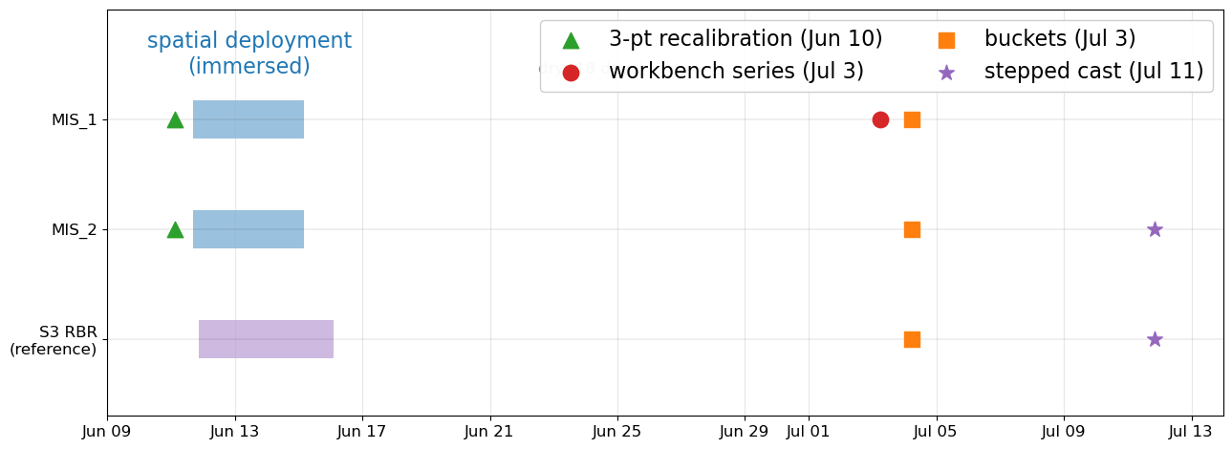
Figure 1 outlines when and for what each system was used.
Figure 1: The timeline when each system in this work was used (2026). Following the 5 day spatial deployment in Mare Island Strait in Vallejo, California, all systems stayed dry until the workbench comparison, followed by the buckets later that afternoon. Finally, both casts with holds were completed 11 July.

Water Samples
6 water samples were used to compare the RBR and MIS_1 on the workbench. The order of the samples, as follows, was established to represent both high and low conditions expected during deployment in a dynamic estuarine environment.
- Two commercially-available calibration standards from Atlas-Scientific, labeled 12,880µS and 80,000µS. The calibration solutions are used for the manufacturer calibration method for the EZO. For all system comparison tests, the RBR remains the reference.
- Two lab-made solutions: 17 PSU and 35 PSU. Samples were made by dissolving 17 grams and 35 grams of NaCl kosher salt in 1L of deionized (DI) water using a stir plate, respectively.
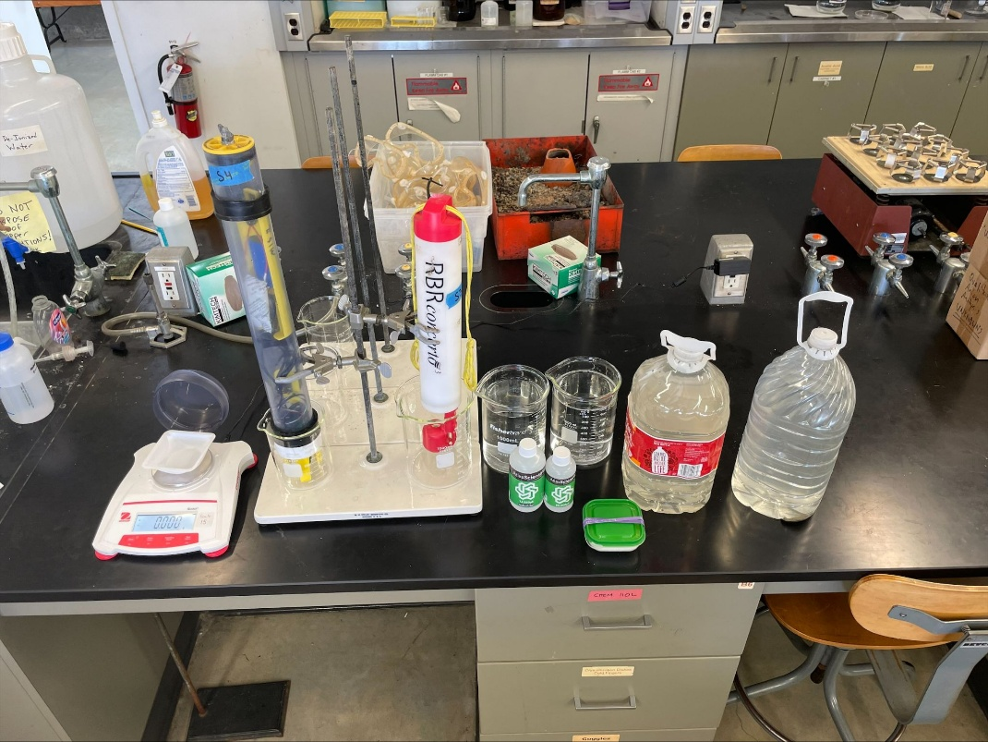
- Two water samples from the San Francisco region of two different salinities: Carquinez Strait (CRQ), representing a brackish estuary, and Pacifica Esplanade Beach (PEB), representing coastal sea water.
B
A
Figure 2: Lab equipment and general testing setup. The SeaLabMOS MIS_1 is #1, RBR is #2, with water samples to the right. Photo taken by Karl.

Both systems require their salinity probes to be fully immersed. Sensors were initially rinsed with DI water, then were sequentially placed in each sample for >1min (the set sample rate of the RBR during the workbench test), before being removed and rinsed with DI water and placed into the next sample. They were shaken “dry”, so a few drops of DI water remained on the system between samples.
Data Processing Methods
The RBRconcerto³’s values for EC and salinity are treated as truth and are thus reported as is without any post-processing. Data from the instrument is accessed via the Ruskin software, exported as a *.nc file and processed in Python.
Temperature: A note on accuracy
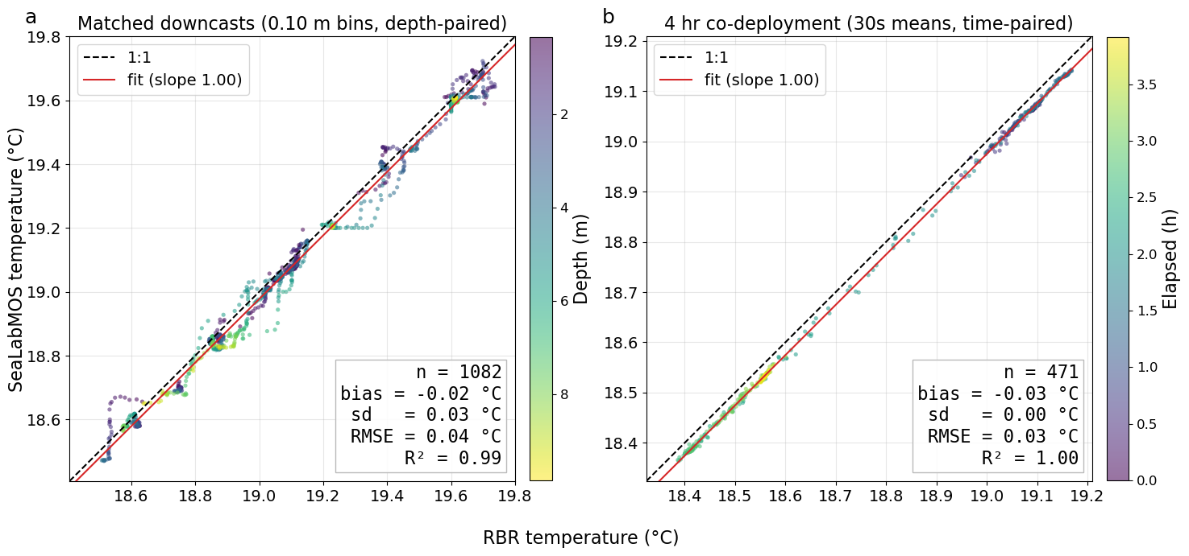
Per the datasheet, the absolute accuracy of the temperature sensor used by the SeaLabMOS CTD is ± 0.1°C between -5 to 50°C[11]. The SeaLabMOS firmware polls the sensor and reports a variable with four significant figures (ex. 18.76).
Figure 3: Panel (a) pools 17 cast-reference pairs collected over 5 days in the same location in Mare Island Strait. Paired casts were separated by a median of 52 s with a max of 5.4 min. Temperature data was binned by depth for each cast. Panel (b) is a 4 hour co-location deployment at the same depth in the same location as (a)’s casts. The temperature range reflects either the flood current, surface heating/cooling, or any combination thereof. The cause of temperature change is not material to the accuracy assessment. Both plots show a very slight negative average bias of -0.025 °C.

Figure 3’s panel (a) gives a mean offset of −0.02 °C with an RMSE of 0.04 °C (n = 1,082). Panel (b) gives a mean offset of −0.03 °C with a residual standard deviation of 0.005 °C (n = 471). The worst-case 0.04 °C is adopted as the working accuracy figure.
Propagating a 0.04 °C error into the practical salinity calculation at fixed conductivity corresponds to a difference of 0.005 PSU at 5 PSU, 0.014 at 15, 0.024 at 25, and 0.031 at 33, all units of PSU, respectively. This is three to twenty times below the platform’s potential best corrected salinity accuracy of ±0.25 PSU. Thus, no temperature correction is applied at any stage; the temperature variable as reported by the SeaLabMOS CTD temperature sensor is passed to gsw.SP_from_C[14] uncorrected.

Salinity
The Atlas Scientific EZO circuit’s datasheet stipulates that “when you enable the salinity output of the EZO circuit it mathematically converts conductivity to salinity using the Practical Salinity Scale (PSS-78)” [12]. The firmware-reported salinity values are inaccurate because the EZO uses 25 °C as the reference temperature without also compensating for pressure. For these reasons, it is disregarded. Therefore, the SeaLabMOS CTD salinity values are obtained using post-deployment data analysis using either the scalar or quadratic steps fully outlined in a how-to document on GitHub[13]. The four possible “final product” salinity variables are:

sal_fw
Salinity computed internally and reported by the EZO using 25 °C hard-coded for temperature compensation and an unknown pressure value for its PSS-78 calculation.

sal_recalc
EC with no correction, using in-situ temperature and pressure from the other two sensors on MIS_1/2.
$EC_mScm = \frac{EC_raw_uScm}{1000}$ (1)
$sal_recalc = gsw.SP_from_C(EC_mScm, t, p)$ (2)
sal_recal_sca
EC_GAIN for MIS_2 was derived by the least-squares fit of the recalculated salinity against the RBR reference over the thirteen equilibrated hold points shown in Figures 6, 7, and 11. This EC_GAIN is applied to the EZO’s reported EC data which is then passed through gsw.SP_from_C[14] as before to obtain the final corrected salinity values for the scalar correction.
$EC_{\text{GAIN}}=\arg{\min_{g}{\sum_{i=1}^{N}{​}}}{\left[SP_from_C\left(g C_{i}, t_{i}, p_{i}\right)-S_{ref,i}\right]}^{2}$ (3)
Where:
- g — trial conductivity multiplier (dimensionless)
- Cᵢ — measured raw in-situ conductivity at hold i, in mS/cm (logged µS/cm ÷ 1000)
- tᵢ, pᵢ — in-situ temperature (°C, ITS-90) and sea pressure (dbar) at hold i
- SP_from_C — PSS-78 practical salinity (gsw.SP_from_C)
- S_ref,ᵢ — RBRconcerto³ reference salinity at hold i
- i = 1…N over the equilibrated hold points (N = 13 for MIS_2)
$EC_mScm = \frac{EC_raw_uScm}{1000}$ (4)
$EC_corr_mScm = EC_GAIN × EC_mScm$ (5)
EC_GAIN = 0.9908 for MIS_2
$sal_recal_sca = gsw.SP_from_C(EC_corr_mScm, t, p)$ (6)
sal_recal_qua
The quadratic equation was derived by the same salinity-residual least-squares fit as the scalar gain with the single multiplier replaced by a two-term conductivity polynomial. Equation 3 calculates the EC_GAIN used for Equation 7 which finds A₁ and A minimizing over the calibration standards, constrained through the origin with no intercept term and initialized at the scalar solution for that unit. The same variable definitions from Equation 3 are used, plus A1 = EC_GAIN (1.4443 for MIS_1) and A2 = 0 to solve for a new A₁ and A₂:
$\left(A_{1},A_{2}\right)=\arg{\min_{A_{1},A_{2}}{\sum_{i}{​}}}\left[SP_from_C\left(A_{1} {EC}_{i}+A_{2} {EC}_{i}^{2}, t_{i}, p_{i}\right)\right.-{rbr_sal}_{i}]^{2}$ (7)
This new A₁ and A₂ is used for the final quadratic correction to the raw EC values.
$EC_mScm = \frac{EC_raw_uScm}{1000}$ (8)
$EC_corr_mScm = A_{1} × EC_mScm + A_{2} × {EC_mScm}^{2}$ (9)
A1 = +0.86331, A2 = +0.0149285 for MIS_1
$sal_recal_qua = gsw.SP_from_C(EC_corr_mScm, t, p)$ (10)
Both of the correction methods minimize the salinity residual against the RBR, but apply the correction to the conductivity, because that is where the EC physics ultimately lies.
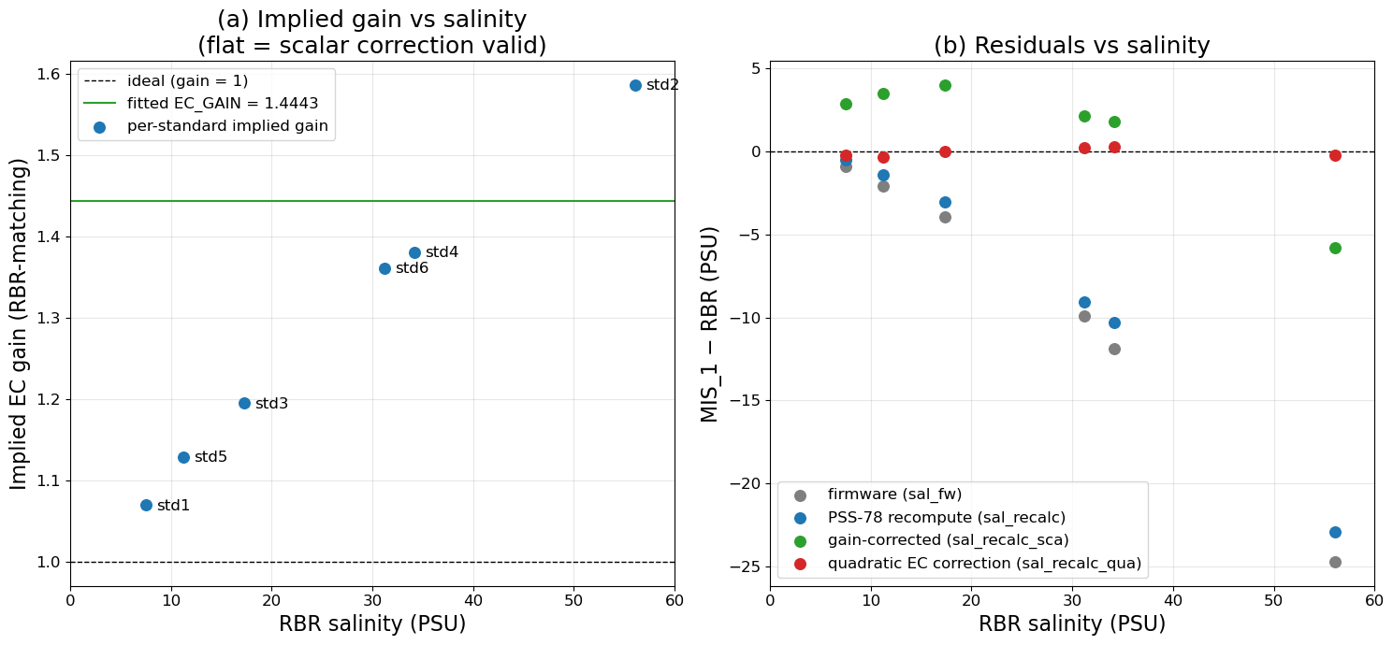
Figure 4 illustrates which data correction method to use. Two independent bucket tests using the CRQ and PEB water agree with MIS_2’s scalar gain correction; its gain line is flat. However, MIS_1’s workbench data shows how using a scalar correction shows a non-linear result.
Figure 4: Panel (a) shows MIS_1’s per-standard implied EC gain drifting non-linearly while the independent bucket tests of MIS_2 are linear. Panel (b) shows the salinity residuals following each calculation method for MIS_1, which also non-linear.

EXPERIMENTS and RESULTS
Field Data
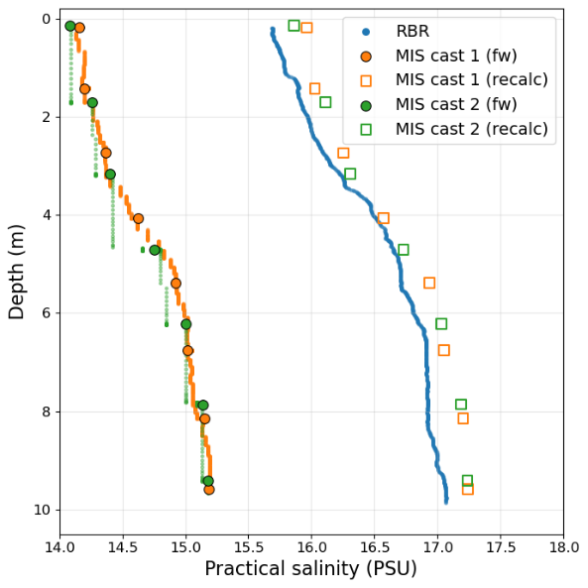
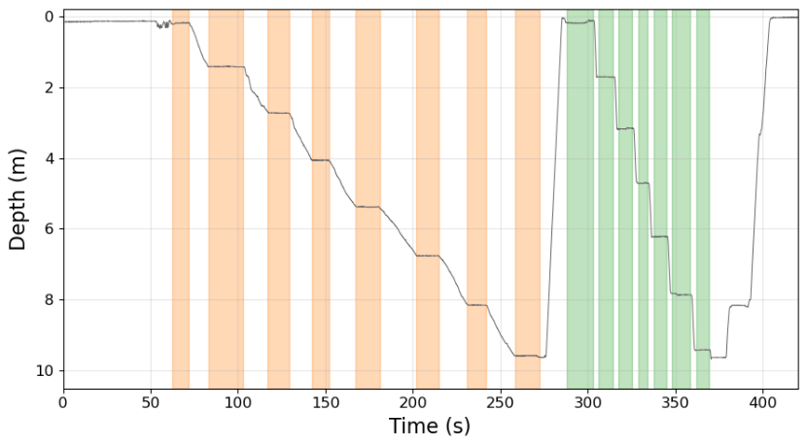
Two sequential casts were completed with the SLMOS CTD MIS_2, one lowering slowly and the second fast, both holding approximately 1.5 meters or so for about 10 s. All casts were done manually by hand. Time and depths were best-estimates by Sophie in the field. Figure 5 shows the two casts (the system was kept on for the duration).
Figure 5: Cast one (orange) with 0.08 m/s median transit rate and 200 s total downcast time. Cast two (green) with 0.52 m/s median transit rate and a 67 s total downcast time
A hold time of 10 s was selected because the salinity sensor has a 90% response time in 1 s[3]. To ensure the sensor had time to equalize, the EC data from the final 5 s of each hold was averaged for that depth point.
Figure 6: Firmware-reported salinity data (fw) from Figure 5’s casts. Note how during Cast 2 the depth value updates faster than the salinity value, causing green downward streaks before the reported salinity value can equalize to the surrounding water.
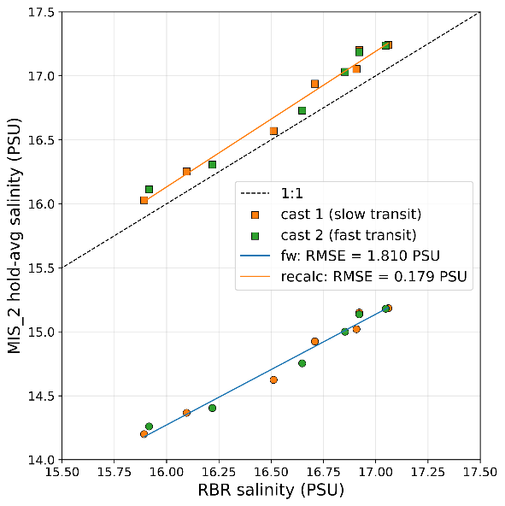
Using the data methods outlined previously, we can recalculate the salinity derived from the raw EC values from the EZO, which by the sensor’s physical nature is taken at the in-situ temperature. The firmware-reported salinity values are shown on Figure 6 and 7 to illustrate how poorly the salinity data product from the EZO can be.
From a 1:1 comparison plot between the two sensors, as in Figure 7, two things become apparent:
Figure 7: A 1:1 comparison plot showing the difference between the EZO’s salinity values and the recalculation method using EC values and the PSS-78 equations via GSW-Python SP_from_C[14].
- The recalculated salinity values closely match the RBR with a root mean square error (RMSE) of 0.179 PSU, and;
- The sensor shows a consistently high bias across all sampled ranges. This high bias is what the scalar correction EC_GAIN of 0.9908 corrects for.
This EC_GAIN value, however, was obtained using field data spanning a narrow range of 1.17 PSU. To test the scalar data correction’s validity two bucket tests were done using the water samples from CRQ and PEB (the same used in the workbench tests). Despite being fit over the very limited range from cast holds (15.85–17.10 PSU), the scalar EC_GAIN correction only calculated 0.21 PSU low at 11.57 PSU (1.82% error, Figure 8 Inset A) and 0.01 PSU low at 32.96 PSU (Figure 8 Inset B).
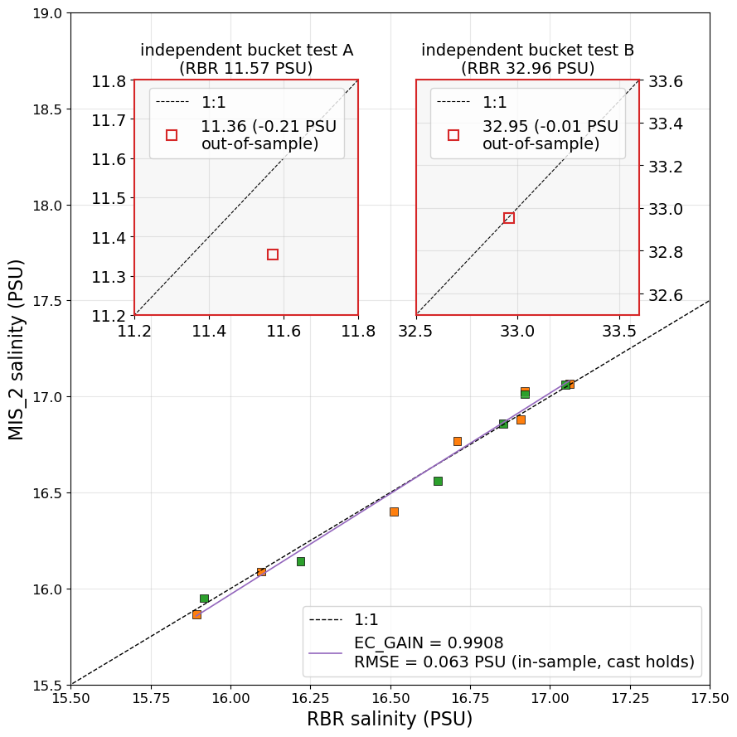
Lab Data
Figure 8: The system-specific EC_GAIN was derived by a least square fit from the cast holds shown on the primary axes and applied to the two bucket tests (insets). The main plot are the resulting salinity values following the EC_
A visual representation of how each data correction method affects the final salinity value is shown in Figure 9. The four possible “final” salinity variables are shown.
Comparing the RMSE values in Figure 9, panel (d) agrees with the quadratic correction method being the best for MIS_1’s final salinity data product.

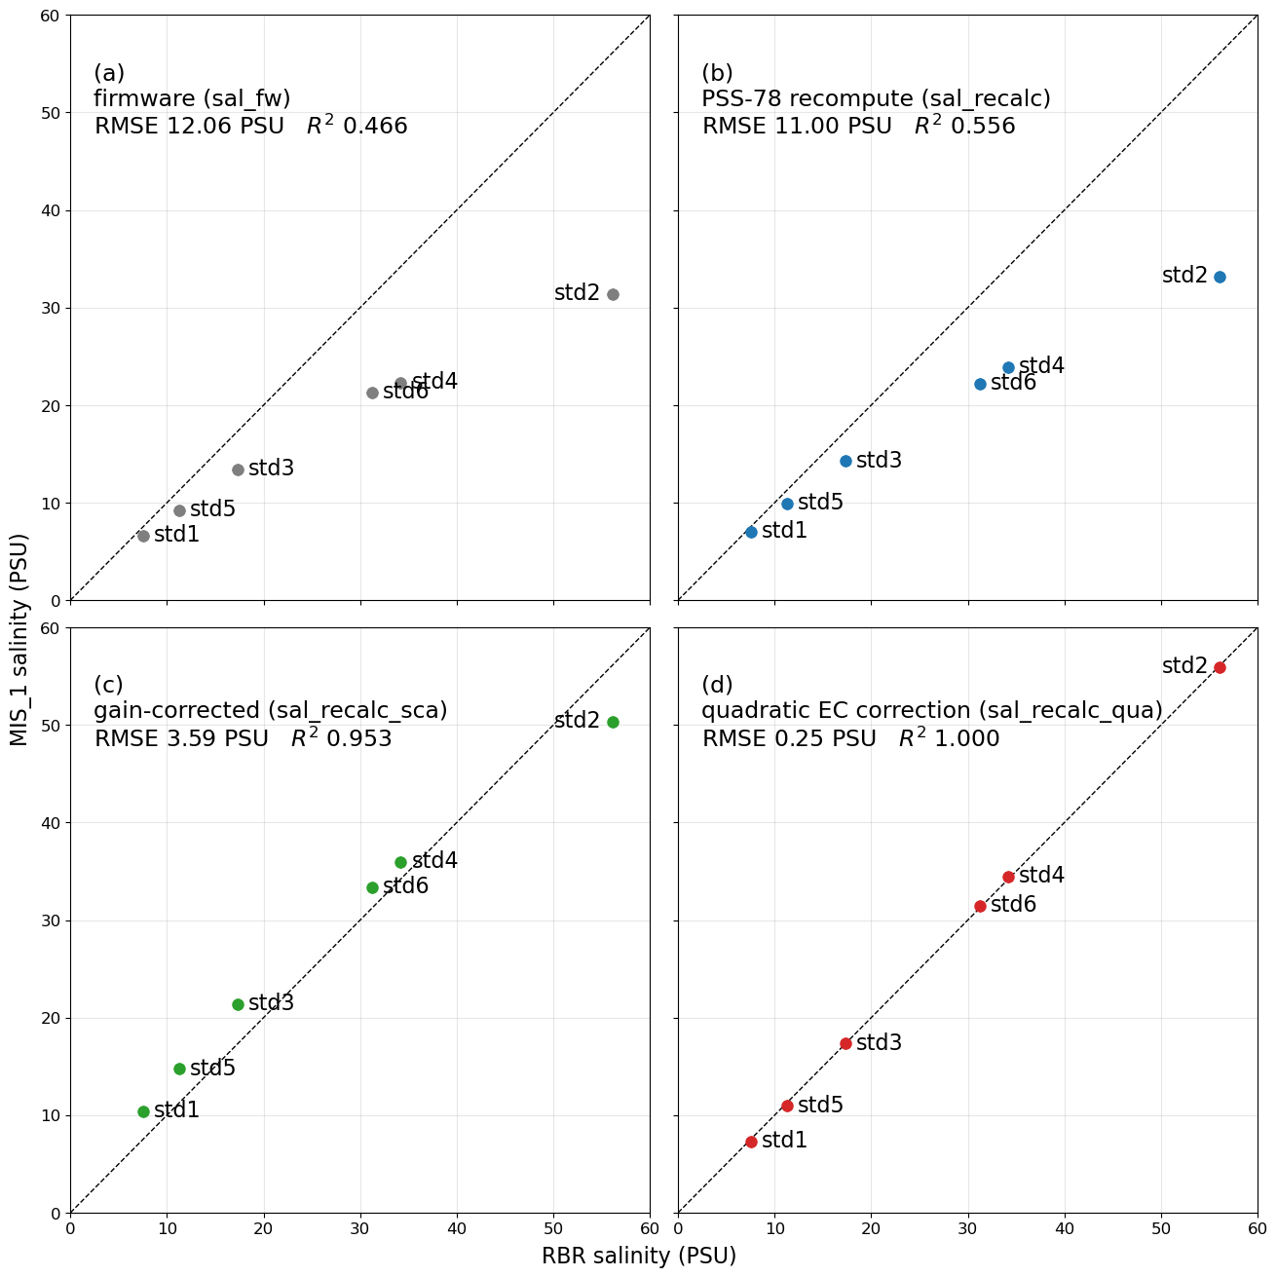
The USGS Accuracy Standard
Figure 9: Comparison of the four salinity calculation methods vs the RBR reference during MIS_1’s workbench testing.
The CRQ and PEB waters were used as samples in the workbench comparison. If we exclude them from the in-sample quadratic correction method used for MIS_1, leaving us with a quadratic based on 4 points instead of the original 6, it is possible to use the bucket tests for an independent test of both systems’ absolute accuracy against the USGS yardstick.
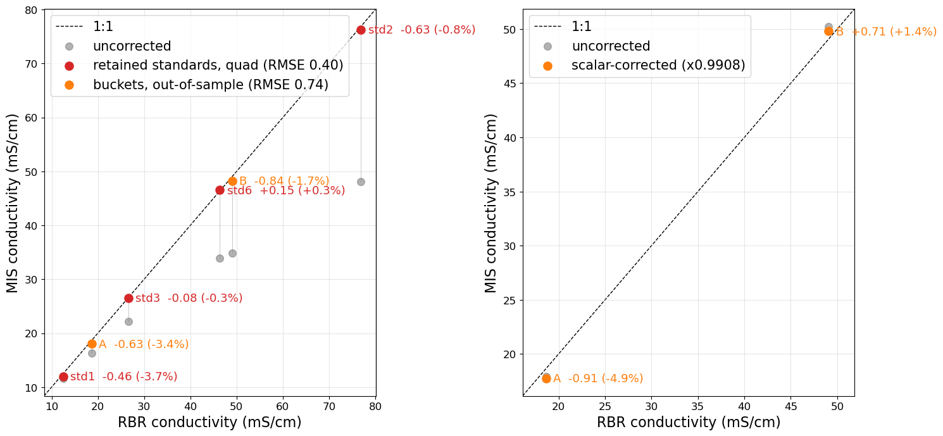
Figure 10: Panel (a) uses a 4-point point quadratic correction using only the red standard points as in-sample, leaving bucket A and B as out-of-sample. Panel (b) shows both out-of-sample bucket data for MIS_2. Both panels show less than 3% error over ~22 PSU.
The in-sample percent error of MIS_1 corrected via 4-point quadratic was on average 1.28% with an out-of-sample average error of 2.55%. The out-of-sample error of MIS_2 via scalar was 3.15%. However, distilling the percent error to one number is disingenuous of system performance.

It’s worth remembering that the USGS yardstick is “±3 percent of the certified values for measurements”[6], not a separate system used for comparison. Both sensors are least accurate at low conductivity and reliable across the mid-to-upper range with 22 mS/cm as an accuracy cutoff: above is within 1.7% of the RBR’s reference while below error rises to 3-5%. This means that both SeaLabMOS CTDs performed with less than 3% error when in water saltier than 22 mS/cm, when compared to our RBR (22mS/cm corresponds to ~15 PSU at 25 °C near the sea surface).

DISCUSSION
Correction Factors
Despite the systems being identically built and using identical firmware, they required two different data correction methods - scalar or quadratic. This resulted in a system-specific correction. This warrants further research to determine whether every SeaLabMOS CTD continues to have a unique correction factor (scalar) or equation (quadratic) and whether new systems built fit into the current correction scheme. The current correction can only be calculated through comparing the EZO against a known-good salinity sensor; in this case, the RBR. This comes with the additional caveat of citizen scientists requiring, if not ownership, access to an expensive system.

Cast Lowering Times and Hold vs No-Hold Casts
The two casts, shown in Figure 11, illustrate how slowly lowering the SeaLabMOS CTD at 10cm/s results in the same sample behavior as adding holds, but with more data collected between hold points. While time is less a factor for shallow casts, completing a 200 m cast at 0.1 m/s would take ~33 minutes. This might be untenable due both to costs associated with vessel time and the physical ability of the person casting entirely by hand. The most time-effective method of casting a SeaLabMOS CTD appears to be fast transit time between holds of 5-10 s. When doing deep casts, a hybrid approach could be applied, where one slowly lowers during the first ~20-50 meters (depending on the estimated depth of the thermocline and/or halocline), then finishes the cast with steps. This method would be consistent with large-scale ocean models that cluster their model output data points nearer the air-sea interface rather than at depth[15] as shown in Figure 12. Further work is required to investigate whether this is a worthwhile deployment method when the deepest a SeaLabMOS CTD has successfully been deployed is 172 m.
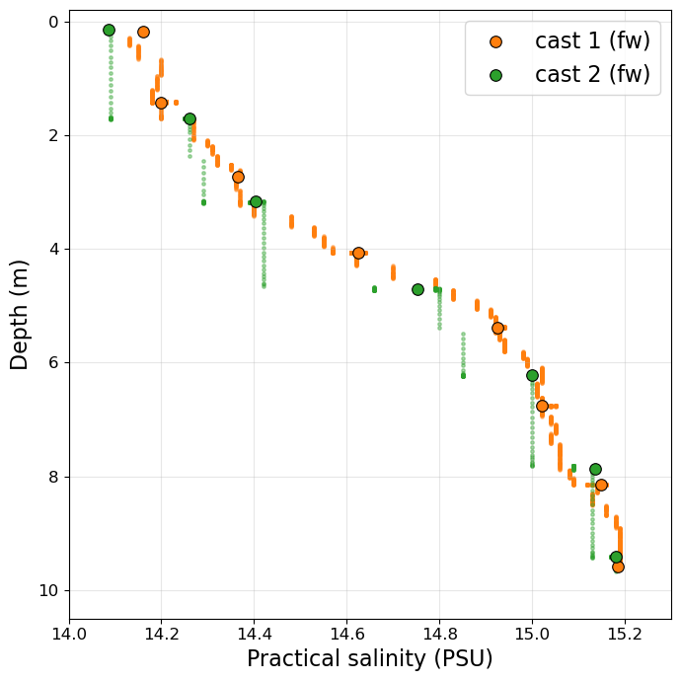
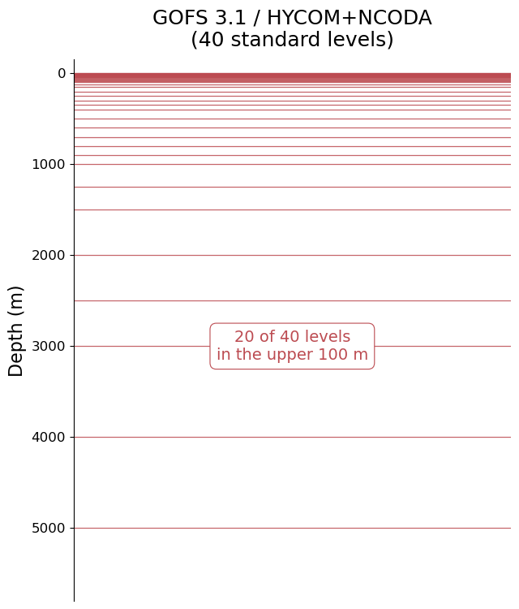
Figure 11: Cast 1 (orange) was lowered slowly with holds, while Cast 2 was lowered quickly between holds. The vertical green lines show how the system was lowered faster than the reported value by the EZO was able to update. All holds cluster with Cast 1’s tween values.
Figure 12: An illustration of the levels in the Global Ocean Forecast System ocean model are shown. 20 of the 40 levels are in the upper 100 meters [15].

Future Work
These experiments attempted to shed light on the viability of using low cost sensors to expand the capability of citizen science when expensive sensors are in limited availability. The authors highlight that in answering this question, multiple new questions revealed themselves which have the capability to contribute further to open source based research. This exposure is reflective of the scientific process and the capacity for low-cost instrumentation to engage curious individuals not only with the world around them, but also with the development of new knowledge.

The key issue with this research, as presented, is the limited sample size for all the data collected. This is emblematic of the issues commonly faced by those attempting to complete accurate oceanographic research, the foremost being cost constraints with a high barrier of entry. From access to the estuary or ocean via vessels where one can cast in desired locations, or simply deeper than alongside a dock, limited purchase of certified calibration solutions (or none at all), and the ability to devote time to the project, cost constraints affect every aspect of type of low-cost oceanographic research.

More research is required to collect more data to expand upon what has already been completed or to investigate further questions. The following areas have been identified for future work:
- More data from the systems is required to both understand the repeatable accuracy of the system and the longevity of system-specific correction factors.
- More lab-made solutions representing fresh water to ~50 PSU, used to perform multiple measurements of the same samples using more SeaLabMOS CTDs (not only with MIS_1) to better compare all systems and check repeatability.
- The SeaLabMOS CTD, being a modular embedded system built by hand, will always have minor differences between identical systems. Future experiments are needed to test effects like wire length and placement inside the waterproof tube to investigate what might be influencing the measurements taken by the sensor. This experiment could compare the SeaLabMOS CTD system to a standalone EZO system.

CONCLUSION
Our experiment confirms the Atlas Scientific EZO™ Conductivity Circuit and Conductivity Probe K 1.0 used in the SeaLabMOS CTD (and other open source low-cost COTS systems[1]) reports values that are less accurate than using the EZO’s EC values to calculate salinity ourselves. Despite this, we’ve shown that users of COTS systems using an EZO can correct their data to be quantitatively reliable through comparative calibrations in the field and on the workbench, use of data post processing, and then scalar or quadratic corrections to the original EC data.

With the corrections applied both SeaLabMOS systems performed with less than a 3% margin of error over 22 mS/cm. However, it’s important to remain suspicious of data collected by the EZO unless bound by recent comparisons to a trustworthy reference. Only the salinity products resulting from the scalar gain or quadratic correction should be viewed as final data, so long as an understanding of the limitations for how they were derived is maintained. Therefore, to ensure accurate data, any SeaLabMOS CTD must be compared to a known-good salinity sensor over the range of salinity values expected during its deployment. This can be done on the bench, in the field, or ideally both. For best system accuracy, comparisons should be done before and after any deployment.

ACKNOWLEDGMENTS
The authors would like to thank Leandro da Costa of RBR for graciously lending the RBRconcerto³ CTD|fast32 for use in this research. Dr. Steve Kielar and Dr. Alex E Parker, oceanography faculty at Cal Poly Maritime Academy, for lab access/equipment and deployment/recovery assistance. Kainani Santos at the Applied Research Laboratory at the University of Hawai’i for paper review and edits. The National Park Service for use of the Balclutha for system deployments.

AI Disclosure
Claude Opus 4.8 was used for assistance writing Python code for the figures and properly formatting the references section. All writing is our own.

REFERENCES
[1] A. Thaler, S. K. Sturdivant, R. Y. Neches, and J. J. Levenson, “The OpenCTD: A low-cost, open-source CTD for collecting baseline oceanographic data in coastal waters,” Oceanography, vol. 37, no. 2, pp. 167–173, Jun. 2024, doi: 10.5670/oceanog.2024.602.
[2] S. Scopazzi, “SeaLabMOS,” GitHub repository. [Online]. Available: https://github.com/sscopazzi/SeaLabMOS. Accessed: Jul. 24, 2026.
[3] Atlas Scientific, “Conductivity probe K 1.0 (Mini) datasheet,” Atlas Scientific Environmental Robotics. [Online]. Available: https://files.atlas-scientific.com/Mini_EC_K_1.0_probe.pdf. Accessed: Jul. 24, 2026.
[4] Atlas Scientific, “EZO™ conductivity circuit — conductivity accuracy graph.” [Online]. Available: https://files.atlas-scientific.com/conductivity_accuracy_graph.pdf. Accessed: Jul. 24, 2026.
[5] S. G. Fulton, J. C. Stegen, M. H. Kaufman, J. Dowd, and A. Thompson, “Laboratory evaluation of open source and commercial electrical conductivity sensor precision and accuracy: How do they compare?,” PLoS ONE, vol. 18, no. 5, Art. no. e0285092, May 2023, doi: 10.1371/journal.pone.0285092.
[6] U.S. Geological Survey, “Specific conductance,” in National Field Manual for the Collection of Water-Quality Data, U.S. Geological Survey Techniques and Methods, book 9, chap. A6.3, 2019, doi: 10.3133/tm9A6.3. [Online]. Available: https://pubs.usgs.gov/tm/09/a6.3/tm9-a6_3.pdf
[7] Vernier Science Education, “What is the difference between salinity and conductivity?,” Technical Information Library, no. 11516, Apr. 15, 2021 (updated May 20, 2024). [Online]. Available: https://www.vernier.com/til/11516. Accessed: Jul. 24, 2026.
[8] RBR Ltd., “A proven standard in CTD sensor technology: RBR’s inductive conductivity cell.” [Online]. Available: https://rbr-global.com/proven-standard-inductive-conductivity/. Accessed: Jul. 24, 2026.
[9] Mettler Toledo, “Reducing common errors in conductivity measurements,” White Paper, Nov. 2012. [Online]. Available: https://www.mt.com/dam/LabDiv/Campaigns/gp/gep/conductivity-reducing-common-errors-EN.pdf. Accessed: Jul. 24, 2026.
[10] S. Scopazzi, “SeaLabMOS build manual,” GitHub. [Online]. Available: https://github.com/sscopazzi/SeaLabMOS/blob/main/SeaLabMOS_Build_Manual.pdf. Accessed: Jul. 24, 2026.
[11] Blue Robotics Inc., “Celsius Fast-Response, ±0.1 °C temperature sensor (I2C).” [Online]. Available: https://bluerobotics.com/store/sensors-cameras/sensors/celsius-sensor-r1/. Accessed: Jul. 24, 2026.
[12] Atlas Scientific, “EZO™ conductivity circuit datasheet.” [Online]. Available: https://files.atlas-scientific.com/EC_EZO_Datasheet.pdf. Accessed: Jul. 24, 2026.
[13] S. Scopazzi, “SeaLabMOS Data Correction Methods,” GitHub. [Online]. Available: https://github.com/sscopazzi/SeaLabMOS/blob/main/SeaLabMOS_Data_Correction_Methods.pdf. Accessed: Jul. 24, 2026.
[14] TEOS-10, “GSW-Python: Gibbs SeaWater (GSW) oceanographic toolbox in Python.” [Online]. Available: https://github.com/TEOS-10/GSW-Python. Accessed: Jul. 24, 2026.
[15] HYCOM Consortium, “GOFS 3.1: 41-layer HYCOM + NCODA global 1/12° analysis.” [Online]. Available: https://www.hycom.org/dataserver/gofs-3pt1/analysis. Accessed: Jul. 24, 2026.

